First Task
- PHP Program to Find the Largest Element in an Array
CODE:
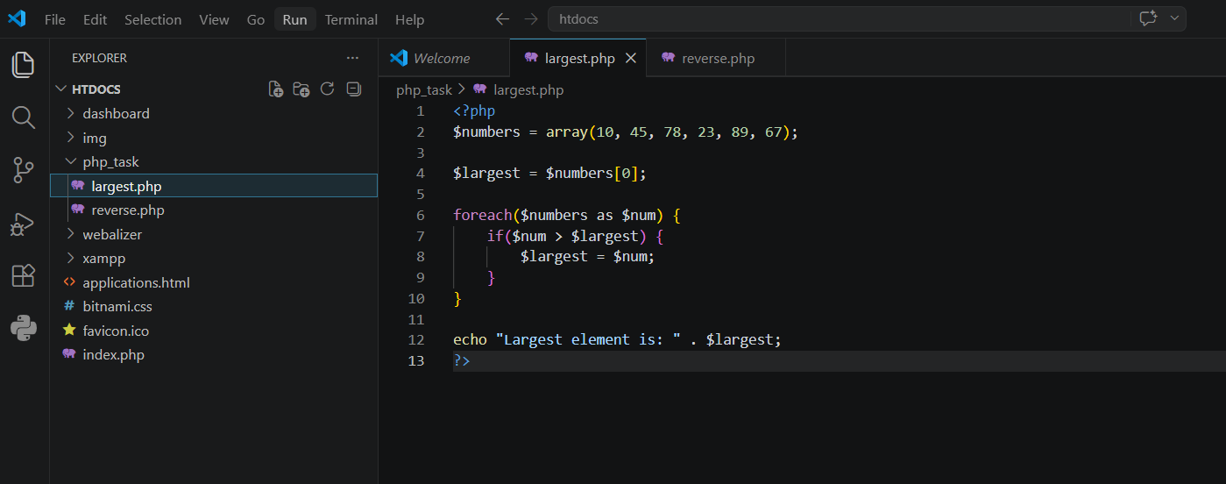
OUTPUT:
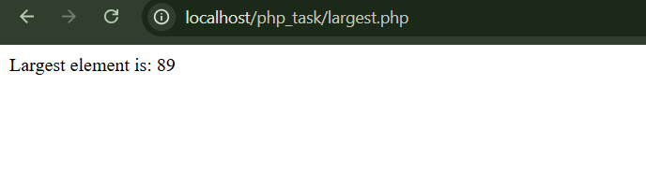
- PHP Program to Reverse a String Using Recursion
CODE:
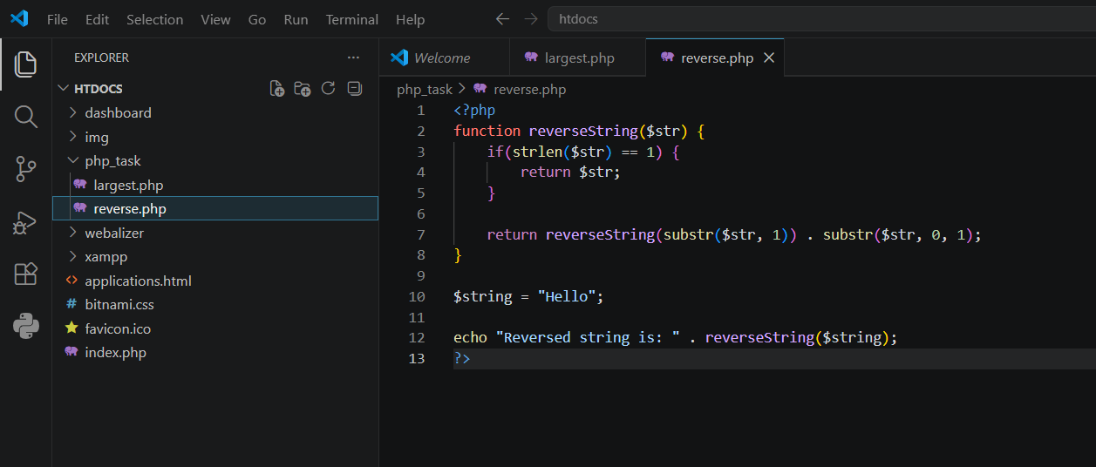
OUTPUT:


